Next Step Forward Guided Reading Framework and the “Science of Reading”
By Jan Richardson, Ph.D.

Introduction
This paper will briefly review the major tenets of the “Science of Reading.” It will also present the Next Step lesson framework (Scholastic, 2016) and explain how it aligns with current reading research.

What is the Science of Reading?
According to the Science of Reading Defining Guide, the Science of Reading is not a reading program, a one-size-fits-all program of instruction, or a single component of instruction. It is a “vast, unfinished, continuously growing, and evolving interdisciplinary body of scientifically based research about reading and issues related to reading and writing.” Because reading science continues to evolve, it has been subject to numerous interpretations when it is applied to instruction.

What are the Common Models of the Reading Process?
Scientific research has yielded several models that attempt to simplify and explain the complexity of the reading process. The most commonly referenced are the Simple View of Reading (Gough & Tunmer 1986), The Reading Rope (Scarborough 2001) and the Active View of Reading (Duke and Cartwright 2021). Although these models illustrate the reading process in different ways, they all agree that beginning readers need a foundation in phonemic awareness and phonics to become skilled at decoding unfamiliar words. They also agree that language comprehension and word recognition are essential.

What is Guided Reading?
Researcher Anita Laquinta describes guided reading as one of the “most important contemporary reading instructional practices in the United States” (Fawson & Reutzel, 2000). Informed by 40 years of research drawing from cognitive science and linguistic principles, guided reading supports all readers, including striving, advanced and English learners (Pearson 2019, Scharer 2019, Clay 2001, 2005, Fountas & Pinnell 2017). During guided reading a teacher meets with a small group of students and differentiates instruction by targeting specific learning needs, providing appropriate scaffolding, and gradually reducing support to promote independence. These three elements (differentiated instruction, scaffolding, and gradual release) are supported by research and embraced by Structured Literacy.

Although guided reading incorporates elements of the Simple View and the Reading Rope, it more fully embraces the recent research depicted in Duke and Cartwright’s model which expands on the Simple View and Reading Rope models by emphasizing the importance of active self-regulation by including strategies, engagement, executive skills, and motivation.

What is the Next Steps Guided Reading Framework?
The Next Steps Guided Reading framework is a research-based, comprehensive, small group lesson design that provides explicit and systematic reading instruction (Richardson, 2009, 2016). The lesson design provides targeted, differentiated instruction in phonemic awareness, alphabetics, phonics, decoding, fluency, vocabulary, comprehension, and writing—critically important elements in a science-based reading program.

A major criticism of guided reading is that the small, instructional groups are based solely on a student’s reading level are not designed to be flexible. However, the Next Steps Guided Reading Framework guides teachers in using authentic formative assessments and daily observations to form small, needs-based, flexible groups that will change in composition as students progress. The framework also emphasizes using challenging text and providing immediate responsive feedback, which is strongly supported by scientific research (Fisher, Frey, and Hattie 2020).
Small flexible groups. CIERA (Center for the Improvement of Early Reading Achievement) investigated the practices of accomplished reading teachers. What they found is a real eye-opener: “Time spent in small group instruction for reading distinguished the most effective teachers from other teachers in the study” (Taylor 2000). Small groups give teachers the opportunity to provide focused, explicit instruction in specific areas of need.
Challenging texts. During guided reading children read texts that are appropriately calibrated to their needs. Research has shown texts used for instruction should not be too easy or too hard. As students read, errors are “expected and celebrated” because they are “opportunities for learning” (Fisher, Frey, and Hattie, 2016, p. 31). Tomlinson (2005) noted, “Our best understanding suggests that a student only learns when work is moderately challenging that student, and where there is assistance to help the student master what initially seems out of reach” (p. 22). In other words, there is a “sweet spot” for learning.
Responsive Feedback. During a Next Step guided reading lesson, teachers provide immediate affirmative and/or corrective feedback. The small-group context provides opportunities for teachers to observe individual students and make in-the-moment instructional decisions that help move a student’s learning forward. “When students are engaged in appropriately challenging tasks, they are more likely to respond to feedback because they need that information to continue growing and learning” (Fisher, Frey, & Hattie, 2016, p. 23).
Next Step Guided Reading aligns with Reading Science
In 1997, Congress convened a National Reading Panel to assess research-based approaches to teaching children to read. The panel’s analysis concluded that the best approach sis one that incorporates what they described as the Five Pillars of Reading:
- Phonemic awareness – the ability to hear, recognize, and manipulate sounds
- Phonics – matching sounds to letters and letter patterns
- Vocabulary – understanding the meaning of words
- Fluency – the ability to read accurately and expressively
- Comprehension – the ability to understand and retain important information to create meaning from text

Scarborough’s Reading Rope (2001) is frequently used to evaluate a reading program’s alignment with the Science of Reading. The elements are background information, vocabulary, language structures, verbal reasoning, literacy knowledge (also referred to as print concepts), phonological awareness, decoding, and sight vocabulary. Each of the skills identified by the Five Pillars of Reading and Scarborough’s Rope is explicitly and systematically taught in the Next Steps Lesson framework.

HOW ABOUT: The following chart lists the Next Steps lesson components and shows how they align with the Science of Reading.

Correlation of Next Steps Lesson and Reading Science
Lesson Component | Description | Elements of Reading Science
Read and Discuss a New Book  Day 1 | After a brief introduction where the teacher introduces unfamiliar vocabulary, the students read the slightly challenging text while the teacher confers with individuals. The teacher teaches a variety of decoding strategies and prompts students to read with fluency and comprehension.  The reading is followed by a group discussion that delves into deeper levels of comprehension and vocabulary. | Phonics  Fluency  Vocabulary  Reading comprehension  Language comprehension  Background knowledge  Language structures  Verbal reasoning  Literacy knowledge  Word recognition  Decoding
Learn Sight Words  Day 1 | Students are engaged in multimodal activities to develop orthographic mapping of high frequency words so that the words become sight words that are quickly recognized without conscious effort. | Phonics  Word recognition  Decoding
Word Study  Day 1 | Teachers use assessments to identify students’ needs and provide explicit, systematic instruction in phonemic awareness, phonics, spelling, vocabulary, and morphology. | Phonemic awareness  Phonics  Vocabulary
Reread Familiar Books  Day 2 | Students reread books to improve accuracy and fluency. The reading is followed by a group discussion that delves into deeper levels of comprehension and vocabulary. | Phonics  Fluency  Vocabulary  Reading comprehension  Language comprehension  Background knowledge  Language structures  Verbal reasoning  Literacy knowledge  Word recognition  Decoding
Guided Writing  Day 2 | Students extend their comprehension by writing about the book. They are encouraged to include high frequency words and/or vocabulary they have learned in previous lessons. | Phonemic awareness  Phonics  Vocabulary  Word recognition  Reading comprehension  Language structures  Literacy knowledge

Although writing is not specifically mentioned in either the Five Pillars of Reading or Scarborough’s reading rope, extensive research has revealed positive effects for integrating reading and writing (Lehr, 1981, Clay, 2001). Writing helps children integrate and solidify many reading skills such as phonics, orthography, word recognition, language structures, newly learned vocabulary, and comprehension.

Closing thoughts
The Next Steps Guided Reading is designed to support teachers as they help children become better readers. In addition to being research-based, the strongest argument for Next Steps Guided Reading is that it integrates reading, writing, and phonics. Teaching phonics and decoding words in isolation does not guarantee children will transfer that knowledge to authentic reading and writing.

As phonics expert Wiley Blevins (2019) states, “Students progress at a much faster rate in phonics when the bulk of instructional time is spent on applying the skills to authentic reading and writing experiences, rather than isolated skill-and-drill work” (page 6). He recommends that at least half of phonics instruction should be applying the skills to authentic reading and writing. The Next Steps Guided Reading framework teaches phonics and spelling and provides for an engaging, purposeful transfer of those skills to reading and writing. The goal of guided reading is simple: Help all students become proficient readers who just can’t wait to read another book!

Appendix A: Next Steps Scope and Sequence for Teaching Phonics

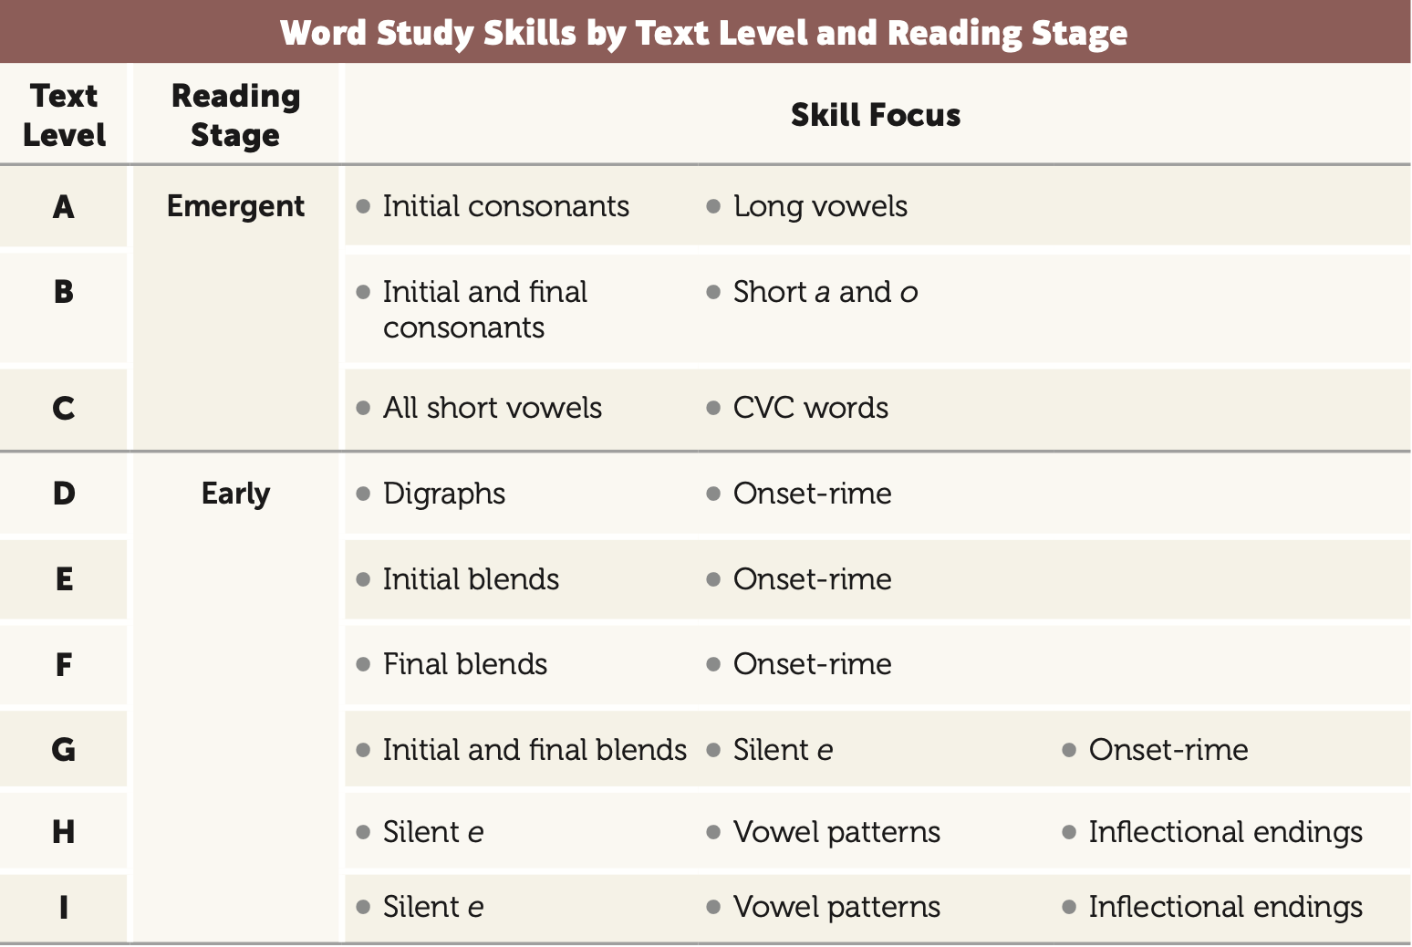
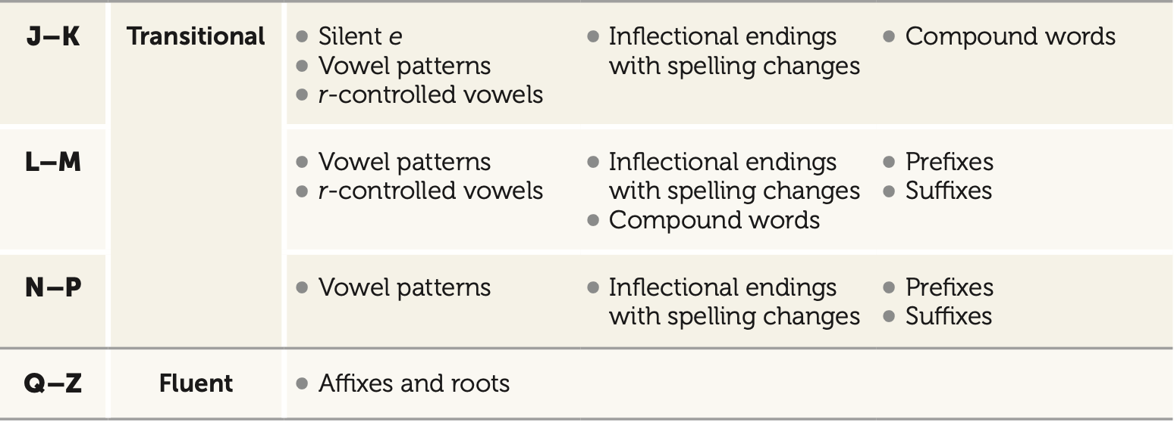
Richardson, J. and Dufresne, M. (2019)
References

Clay, M.M. (2001). Change over time in children’s literacy development. Portsmouth, NH: Heinemann.

Clay, M.M. (2005). Literacy lessons designed for individuals: Part two: teaching procedures. Portsmouth, NH: Heinemann.

Developing early literacy: Report of the National Early Literacy Panel. (2001). Retrieved from
http://lincs.ed.gov/publications/pdf/ NELPReport09.pdf Ford, M., & Opitz, M. (2011).

Duke N.K., and Cartwright, K.B. (2021). The Science of Reading Progress: Communicating Advances Beyond the Simple View of Reading. Reading Research Quarterly 56(S1), S25-S44. https://doi.org/10.1002/rrq.411

Fawson, P. and Reutzel, R. (2000). But I only have the basal: Implementing guided reading in
the early grades. The reading teacher, 54 (1), 84-97.

Fisher, D., Frey, N., and Hattie, J. (2016). Visible Learning for Literacy: Implementing the
practices that work best to accelerate student learning. Thousand Oaks, CA: Corwin.

Fountas, I., and Pinnell, G. S. (2017). Guided Reading: Responsive Teaching across the Grades. New York: Scholastic.

Gough, P. and Tunmer, W. (1986). Decoding, reading, and reading disability. Remedial and special education, 7, 6-10.

laquinta, A. (2006). Guided reading: A research-based response to the challenges of early
reading instruction. Early Childhood Education Journal, 33(6), 413–418.

Pearson, D. (2019). Does research really matter in shaping language and literacy policy? Presentation at the International Literacy Association, New Orleans.

Scharer, P. (2019). What’s the fuss about phonics and word study? Journal of Reading Recovery, Spring, pp. 15-26.

Report of the National Reading Panel. (2006, August 31). Retrieved from
https://www.nichd.nih.gov/publications/pubs/nrp/Pages/ findings.aspx

Richardson, J. (2016). The next step forward in guided reading: An assess-decide-guide
framework for supporting every reader. New York, NY: Scholastic.

Richardson J. and Dufresne, M. (2019). The Next Step Forward in Word Study and Phonics.
Reading. New York, NY: Scholastic.

Scarborough, H. S. (2001). Connecting early language and literacy to later reading (dis)abilities: Evidence, theory, and practice. In S. Neuman & D. Dickinson (Eds.), Handbook for research in early literacy (pp. 97–110). New York, NY: Guilford Press.
Science of Reading Defining Guide, retrieve from https://www.thereadingleague.org/what-is-the-science-of-reading/defining-guide-ebook/

Taylor, B. M., Pearson, P. D., Clark, K., and Walpole, S. (2000). Effective schools and
accomplished teachers: Lessons about primary-grade reading instruction in low- income schools. Elementary School Journal, Vol. 101, pp. 121–165.

Tomlinson, (2005)

Wiley, Blevins (2019). Meeting the Challenges of Early Literacy Instruction. International Literacy Association Literacy Leadership Brief.

